Web Application Firewall IP Address Lists with ORM Stack

Contents
1. Introduction 3
2. Workflow diagram to deploy the stack 3
3. Create stack for WAF IP Address Lists 4
4. Plan the Job 6
5. Apply the Job 7
6. Verify in the Console 8

Introduction

IP address lists allow to define a list of IP addresses to use in Edge policy configurations. The IP addresses in the list can be a valid IPv4 address, a subset, or CIDR notations. IP Address Lists can be used for whitelisting purposes, where only traffic from specific IP addresses or ranges is allowed to access the web application. This provides an added layer of security by restricting access to known and trusted sources.

Workflow diagram to deploy the stack

Below diagram shows how the Terraform Artifact are applied in the OCI. While creating a ORM stack, using terraform deliverables Init, Plan and Apply is the flow to provision the resource in the OCI. We can have the deliverables in any of below.

- GitLab/GitHub Repo
- Bitbucket
- Can be in folder/.zip in the local disk
- Object Storage Bucket
- Can be in compartment
- Oracle provided Template



Create stack for WAF IP Address Lists

Go to OCI Console Developer Services Resource Manager Stacks select the compartment Create Stack

My Configuration Folder Browse Select the “ip_address_lists” folder that contains the terraform Upload

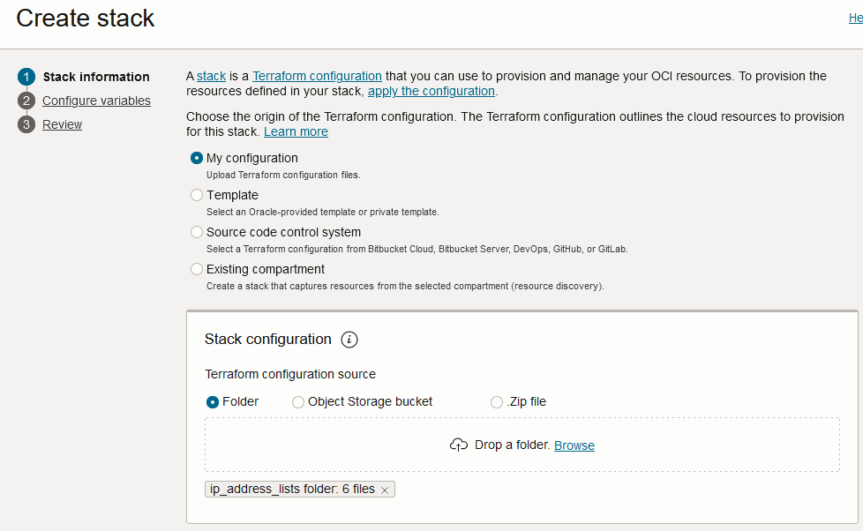

Select the parameters as per the below screens,
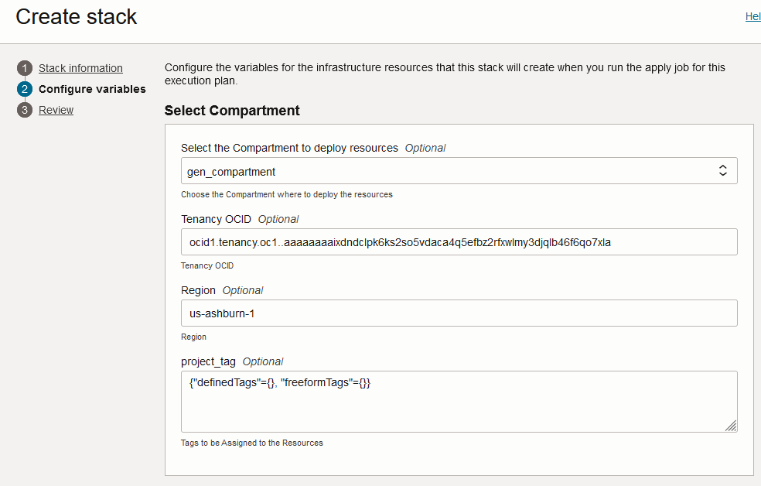
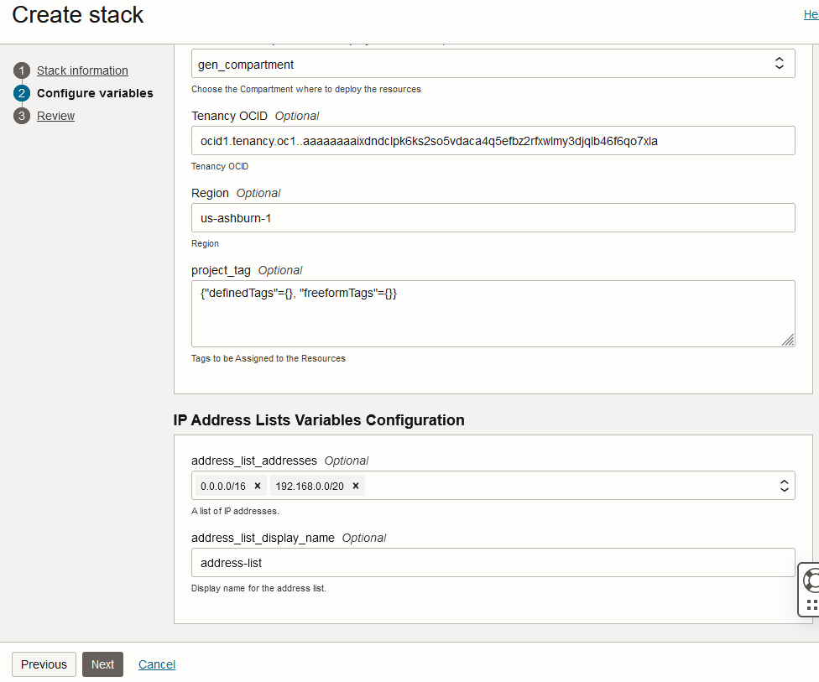
Click “Next”

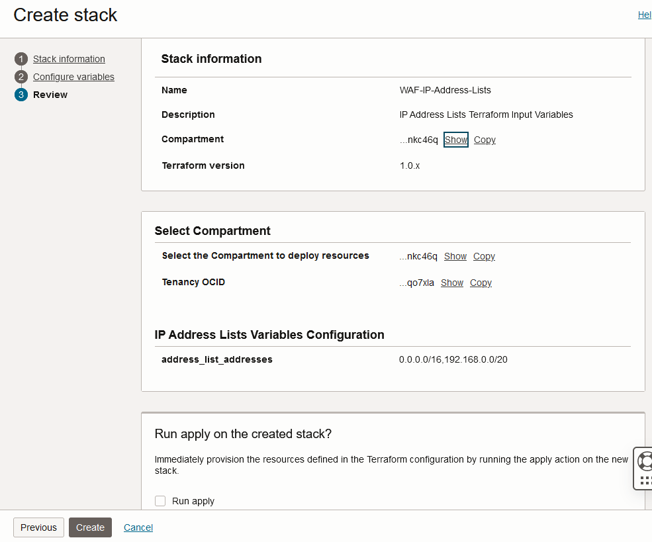
Click “Create”

Plan the Job

Click the “Plan”
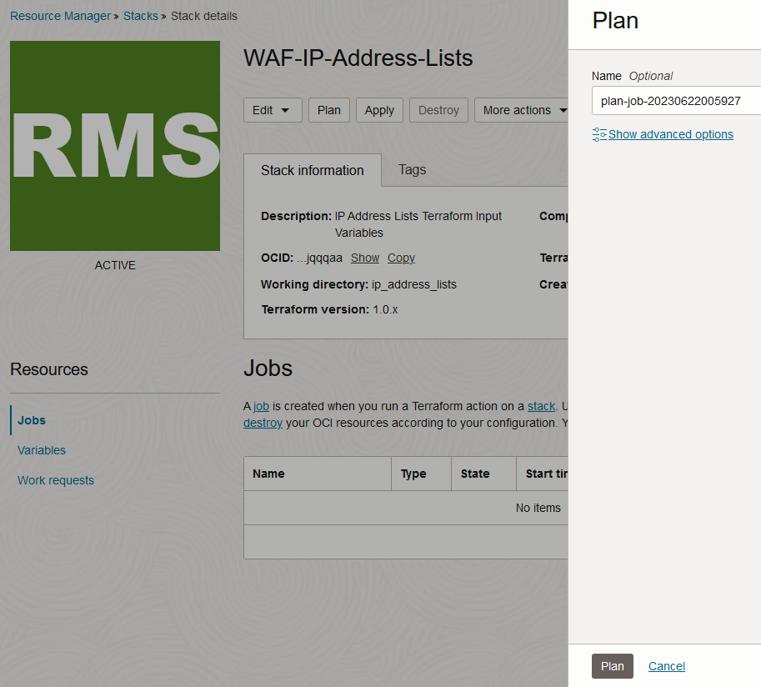

Verify the Plan is successful.

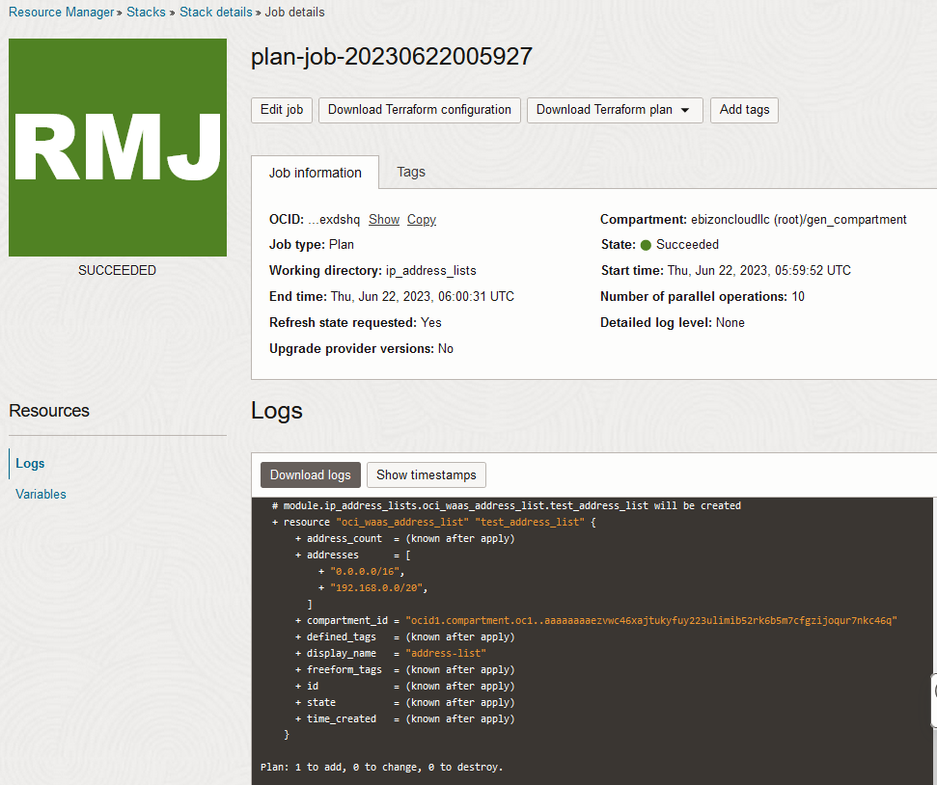

Apply the Job

Once the “plan” is success, now click “Apply”

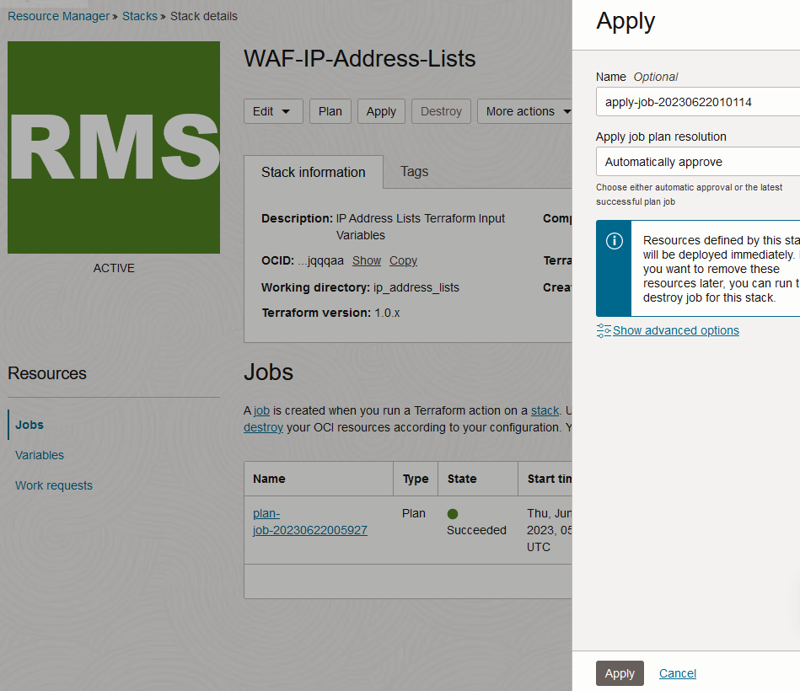

Verify the Apply is successful.

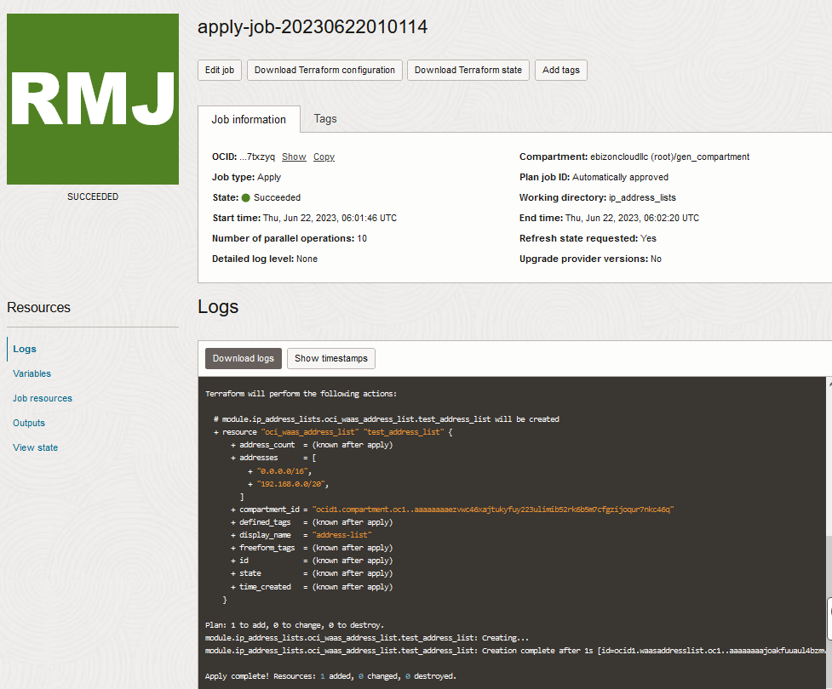

Verify in the Console

Go to OCI Console Web application firewall OCI Edge policy resources IP address lists

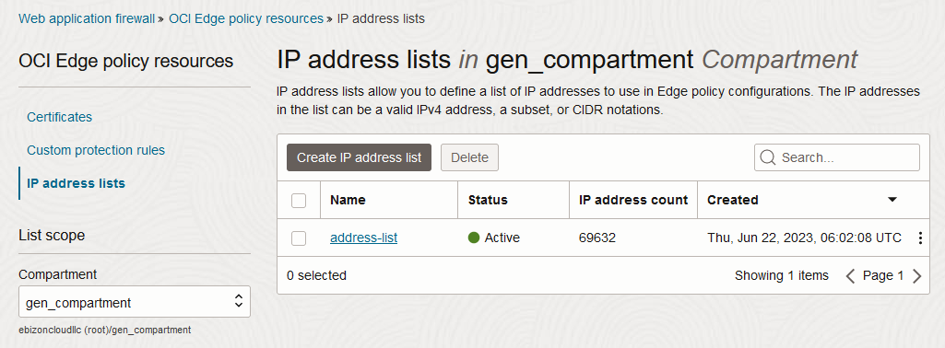

Web application firewall OCI Edge policy resources IP Address Lists IP address lists details

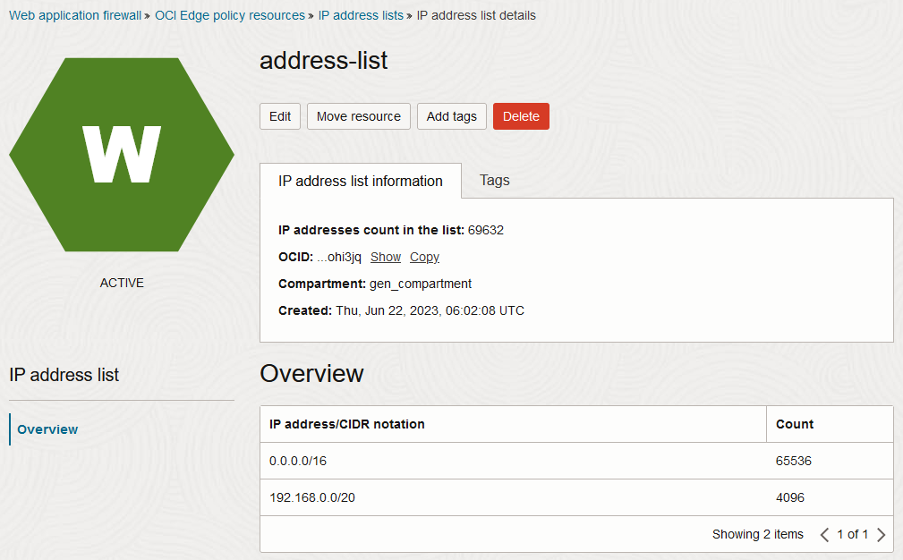

# END #

